**Project Design Phase-I**

**Solution Architecture**

|  |  |
| --- | --- |
| Date | 19 September 2022 |
| Team ID | PNT2022TMID34036 |
| Project Name | AI-powered Nutrition Analyzer for Fitness Enthusiats |
| Maximum Marks | 4 Marks |

**Solution Architecture:**

Solution architecture is a complex process – with many sub-processes – that bridges the gap between business problems and technology solutions. Its goals are to:

* Increasing demand for health assessment and rising health consiuosness is anticipated to drive market growth in the fitness app market
* The model analyse the image and detect the nutrition .
* Nutrition Analysis is the process of determining the nutritional content of food.
* Analysis of personel health metrics has become possible because of advance in Artificial Intelligence.

**Solution Architecture Diagram**

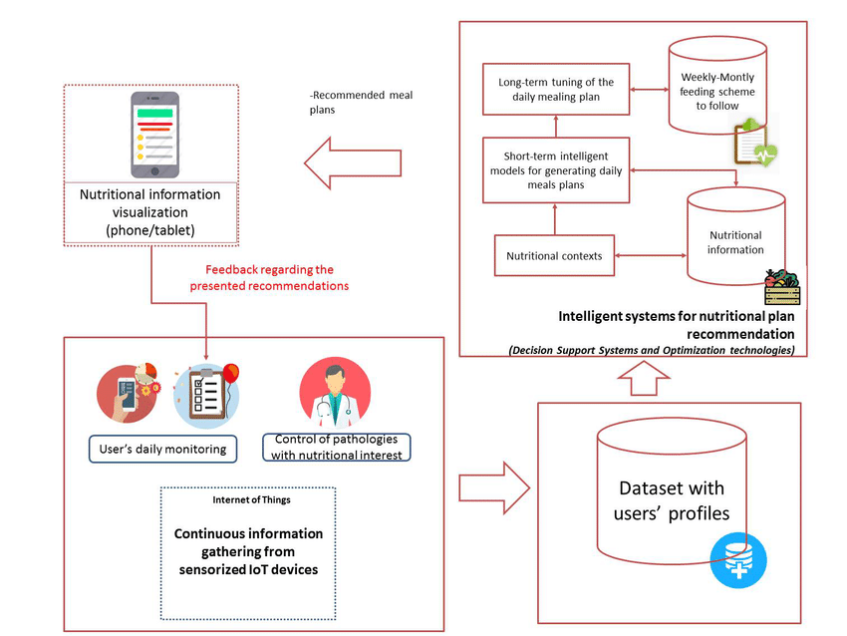

Fig. Architecture for Nutrition Analyzer for fitness enthusiasist